Code Checker using DFAs

By Dominic Rossillo

CMPT 440

Professor Rivas

May 2, 2016

How to install the code checker from Git-Hub:

Go to the GitHub repository at <https://github.com/DominicRossillo/Pablo-Labs> . Here you can either download the Files contained in the Mile Stone two folder or you can clone the entire repository using git clone <https://github.com/DominicRossillo/Pablo-Labs.git> . Once you have done this you will have the project files for milestone two locally on your computer. Use the import function in Eclipse in order to run the project or use the jar file in the Milestone2 folder to run it by typing java –jar Milestone2.jar when your current directory is the git repository.

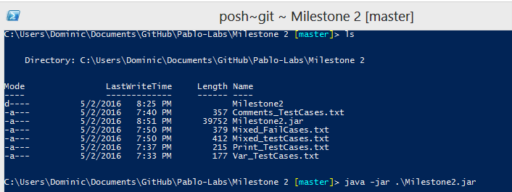

Or

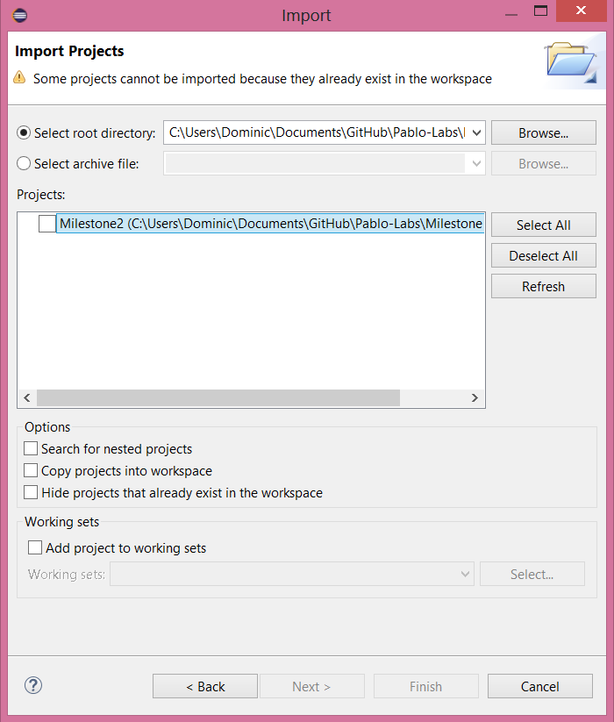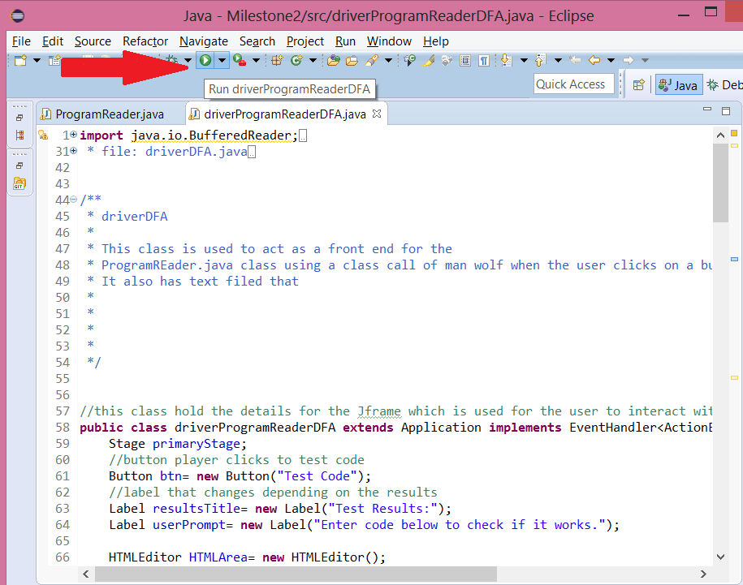

Using the Code Reader:

Once you have downloaded and have the code reader running you can begin to use the GUI seen here:

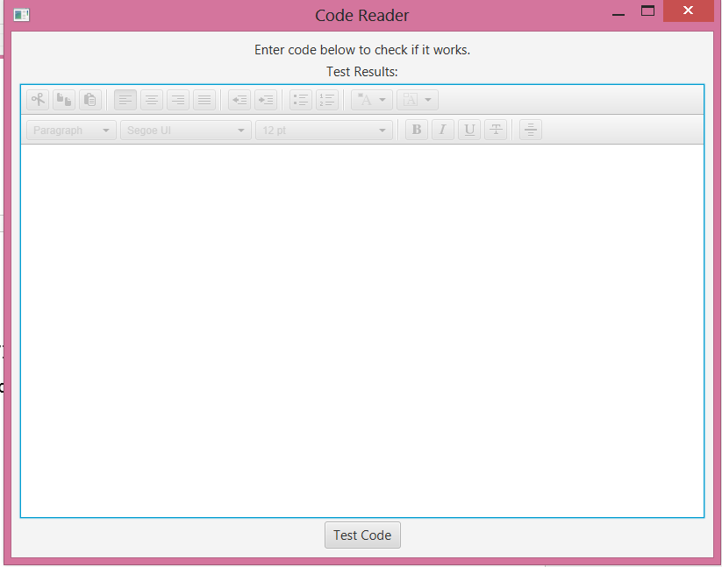

In the GUI the user is allowed to write, copy, and paste text from and into the HTML text editor. The HTML text editor takes any code you want and tells you if it is valid for the Language. It will color code different parts of the code to let the user know which lines of code are print statements, variables, string, comments, and errors. These pieces are color coded blue, purple, orange, green, and red respectively. Errors will color all the code after the last correct symbol red, allowing the user to see where their code hit an error so that they may fix it.

Inside of the repository that you downloaded there are several text files which you can look at for examples of code that works and doesn’t work. In order to use it just copy and paste individual lines into the HTML editor and press the button to see the results.

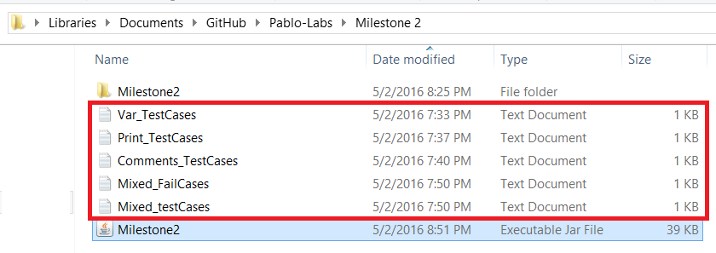

Once you have clicked the button you will see results like these:

